
January monthly report
……....................................
Dr. Pongkarn Chakthranont
Project:
Advancing Integrated Materials and Devices for Electrochemical CO₂ Reduction (AIM-COR)
Sothearoth Heng (ID: 803198)
Under the supervision of
Dr. Pongkarn Chakthranont
Contract Number: NCR-NN-2026-25421-EN
January 2026 report

- To-do list in January
  - Optimization of Fuel cell – CO2RR coupling system for direct flue gas conversion
  - Recollecting the influence of Pt/C catalyst loading on ORR performance in CO2RR-ORR coupling system (Pt/C || BPM || Ni foam)
- Experimental Procedure
Synthesis of NiSAC by pyrolysis method
The synthesis of NiSAC catalyst was followed by our previous work. Initially, nickel phthalocyanine (NiPc), urea, and dicyanamide precursors were stoichiometrically weighed according to mass ratios of x:5:5, wherein urea and dicyanamide were maintained at 5 g each while varying the NiPc content (x = 0.25, 0.5, 1.0, and 2.0 g). Subsequently, the mixture was thoroughly mixed and ground until a homogeneous midnight blue powder was obtained. The fine powder was then transferred into a quartz boat covered with a capsule lid and subjected to polymerization at 800 °C (ramp rate = 10 °C·min⁻¹) in a horizontal tube furnace under an argon atmosphere (flow rate = 200 sccm) for 2 h. The as-prepared xNiSAC catalysts with different NiPc contents were finally obtained and labeled as 0.25NiSAC, 0.5NiSAC, 1.0NiSAC, and 2.0NiSAC.

Preparation of NiSAC cathode electrode via spray coating method
The NiSAC gas-diffusion electrode was fabricated by spray coating onto Sigracet 39BB carbon paper or hydrophilic carbon cloth substrates. Typically, 150 mg of as-prepared NiSAC and 381 μL of XC-2 ionomer were ultrasonically dispersed in 10 mL of isopropanol (IPA) for at least 1 h to form a homogeneous dark colloidal suspension. The ink suspension was subsequently spray-coated onto a 11 x 11 cm² carbon substrate using an automated, custom-built spraying setup equipped with a syringe pump operating at a flow rate of 0.6 mL min⁻¹ on a hotplate maintained at 130°C, yielding a catalyst mass loading of 1.8 ± 0.1 mg.cm⁻².
Note: a bottle of ink suspension containing 150mg of Ni-SAC catalyst yields only ~ 0.7 ± 0.1 mg.cm⁻².

Preparation of Pt/C electrode via spray coating method
100 mg of 20-40%Pt/C catalyst and 217.4 μL of 5%v/v Nafion binder were ultrasonically dispersed in 10 mL of isopropanol (IPA) for at least 1 h to form a homogeneous dark colloidal suspension. The ink suspension was subsequently spray-coated onto a 6 x 6 cm² carbon substrate using an automated, custom-built spraying setup equipped with a syringe pump operating at a flow rate of 0.6 mL min⁻¹ on a hotplate maintained at 100°C, yielding a catalyst mass loading of 1.0 ± 0.1 mg.cm⁻².
Note: 7-8 ml of ink solution containing 100mg of 20-40%Pt/C catalyst yields 1.0 ± 0.1 mg.cm⁻².

Electrochemical measurements in proton exchange membrane (PEM) fuel cell
5cm² PEM fuel cell operational set-up
A 5cm² PEM fuel cell was used to evaluate the deoxygenation performance of simulated flue gas (SFG, 15%CO₂ and 5%O₂ in N₂) under modulated operating conditions. The 20%-40%Pt/C (2.5 x 2.5 cm²), Nafion 211 (25µm, 4.5 x 4.5 cm²), and 20-40%Pt/C or 0.5Ni-SAC (2.5 x 2.5 cm²) were employed as the anode, membrane, and cathode electrode, respectively. The humidified 20ml/min of H₂ and 30ml/min of SFG gas streams were introduced into the anode and cathode sides, respectively. Prior the test, the cell was activated through operating an OCV measurement for 30min, followed by electrochemical impedance spectroscopy (EIS). The cathodic outlet was directly injected into an on-line gas chromatography to quantify the O₂, H₂, and CO₂ gases.

- Results
Optimization of Fuel cell – CO2RR coupling system for direct flue gas conversion
Previous studies have demonstrated that direct electrochemical conversion of flue gas suffers from intrinsically poor CO selectivity and operational instability due to the thermodynamic and kinetic favorability of the oxygen reduction reaction (ORR) over the carbon dioxide reduction reaction (CO₂RR). Even low concentrations of oxygen strongly compete for electrons at the cathode, resulting in parasitic current loss and rapid performance degradation. To address this fundamental limitation, we propose a coupled CO₂RR–fuel cell operation strategy in which flue gas is first electrochemically deoxygenated in a proton-exchange membrane (PEM) fuel cell prior to CO₂ electrolysis. In this configuration, oxygen is selectively removed via ORR at the fuel cell cathode, while hydrogen oxidation at the anode sustains charge balance and simultaneously generates electrical power.

As shown in the I–V–P curves in Figure 1a and b, the symmetrical cell configuration using a 20 wt% Pt/C catalyst exhibited a wider current density range in fuel-cell mode and a higher maximum power density (P_{max}) than the asymmetric system employing a 20 wt% Pt/C anode and a 0.5Ni-SAC cathode. These results indicate that the symmetrical 20 wt% Pt/C configuration requires less energy to remove oxygen from the SFG stream at the cathode. To determine the optimal applied current density for complete oxygen removal from SFG, deoxygenation experiments were conducted in a PEM fuel cell using flow rates of 30 mL min⁻¹ SFG and 20 mL min⁻¹ H₂ over an applied current range of 300–500 mA. As shown in Figure 1c, the residual oxygen concentration was 1.92% at an applied current of 300 mA, with no detectable byproducts. Increasing the applied current to 450 mA further reduced the oxygen content to 0.42% and also accompanied by an FE(H₂) of 5.45%. Further increasing the applied current to 500 mA resulted in only a marginal improvement in oxygen removal, while FE(H₂) increased substantially to ~16%, indicating the onset of oxygen mass-transport limitation at high current density. In contrast, the fuel-cell system employing a 0.5Ni-SAC cathode exhibited significantly poorer oxygen removal performance, with a residual oxygen concentration of 1.94% and a high H2 formation with FE(H₂) ≈ 43% at an applied current of 500 mA, compared to the symmetrical 20 wt% Pt/C system. These results suggest that, in the CEM cell configuration, the high proton flux at the 0.5NiSAC catalyst surface promotes competitive hydrogen evolution over oxygen reduction, leading to inferior deoxygenation performance.
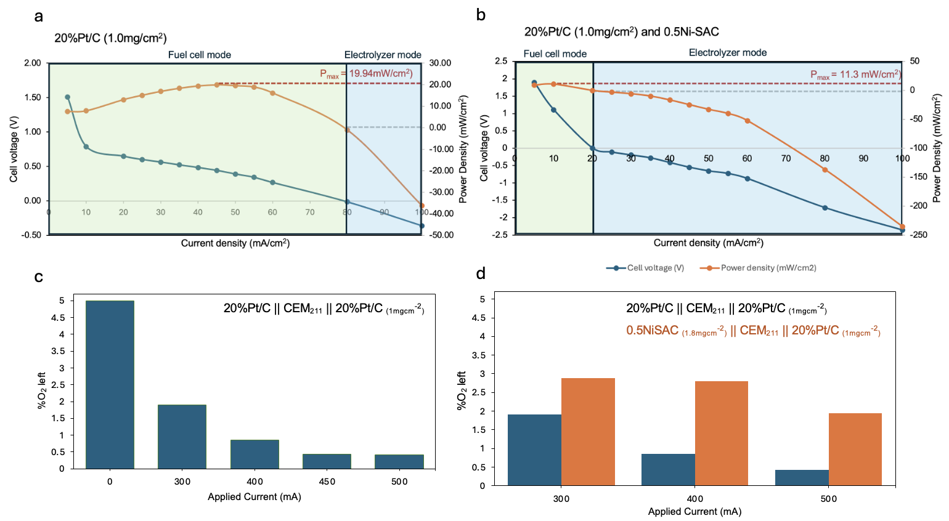
Figure 1. Polarization curve and power density for PEM Fuel cell of (a) symmetrical cell of 20%Pt/C (1mg/cm²) and (b) 20%Pt/C (1mg/cm²) anode and 0.5NiSAC cathode. Deoxygenation of simulated flue gas (15%CO₂ and 5%O₂ in N₂) of (c) 20%Pt/C (1mg/cm²), and (d) comparison of 20%Pt/C (1mg/cm²) and 20%Pt/C (1mg/cm²) anode and 0.5NiSAC cathode under 30ml/min SFG feed and 20ml/min H₂ at 300– 500mA.

Influence of 40%Pt/C catalyst loading on ORR activity in Pt/C || BPM || Ni foam system
To further elucidate the influence of Pt/C loading on ORR performance, SFG deoxygenation experiments were systematically performed using cathodes with Pt loadings of 0.24, 0.40, 0.72, and 1.00 mg cm⁻². As shown in Figure 2, comparable ORR activities were obtained for Pt loadings of 0.24 and 0.40 mg cm⁻², yielding residual oxygen concentrations of approximately 1.76% and 1.91%, respectively, at an applied potential of 2.50 V. Increasing the Pt loading to 0.72 mg cm⁻² led to a pronounced enhancement in ORR performance, as evidenced by a substantial reduction in the residual oxygen concentration to 0.86% at 2.50 V. In contrast, further increasing the Pt loading to 1.00 mg cm⁻² resulted in a slight deterioration in ORR activity, with the residual oxygen concentration increasing to 0.95% under identical operating conditions. Based on these results, a Pt loading of 0.72 mg cm⁻² — corresponding to a 40 wt% Pt/C catalyst loading of 1.8 mg cm⁻² was identified as the optimal catalyst loading for efficient SFG deoxygenation.
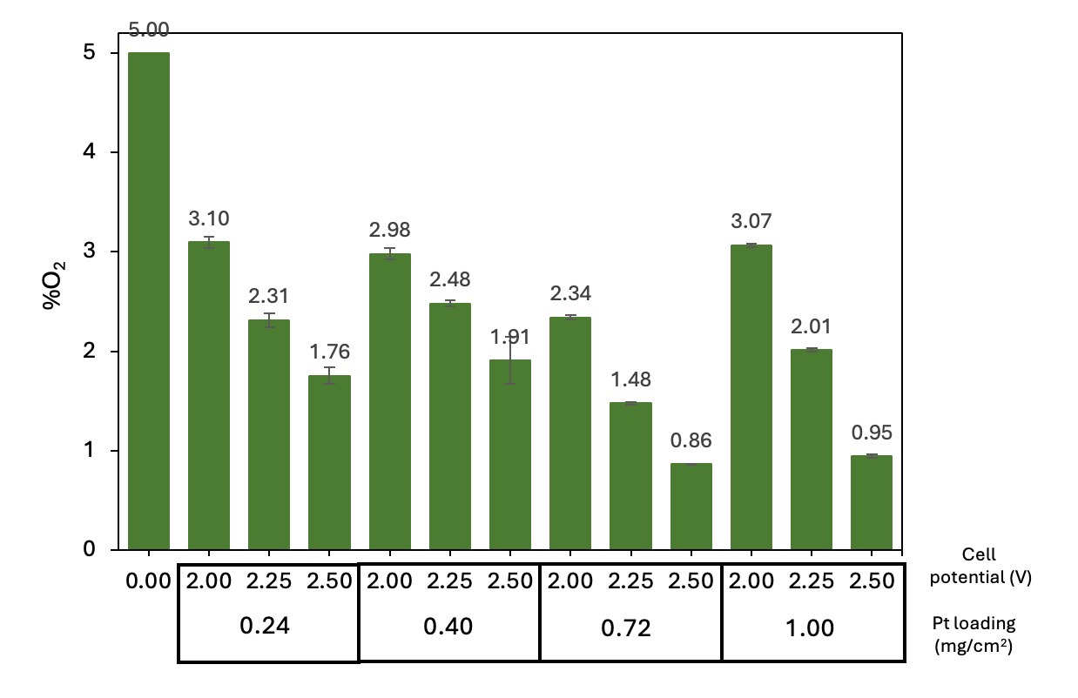
Figure 2. Oxygen removal system. Deoxygenation of simulated flue gas (15%CO₂ and 5%O₂ in N₂) of ORR system (40%Pt/C || BPM || Ni foam) with varied 40%Pt/C loadings under 50ml/min SFG and 8ml/min of 1M KOH anolyte at potential range of 2.0-2.5V.

Upcoming tasks
- Optimization of PEM fuel cell system:
  - 40%Pt/C catalyst loadings: 0.6, 1.0, 1.8, 2.5 mg/cm²
  - Cell and humidifier temperature: 25, 40, 60C
- Investigation of PEM fuel cell-CO2RR coupling system under an optimum condition

